**Problem Statement:**

You work for XYZ Corporation. To maintain the security of the AWS account and

the resources you have been asked to implement a solution that can help easily

recognize and monitor the different users.

**Tasks To Be Performed:**

1. Create policy number 1 which lets the users to:

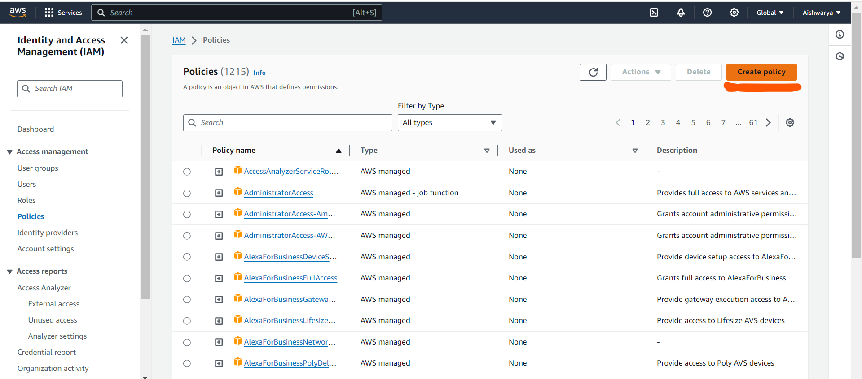

1. Access S3 completely

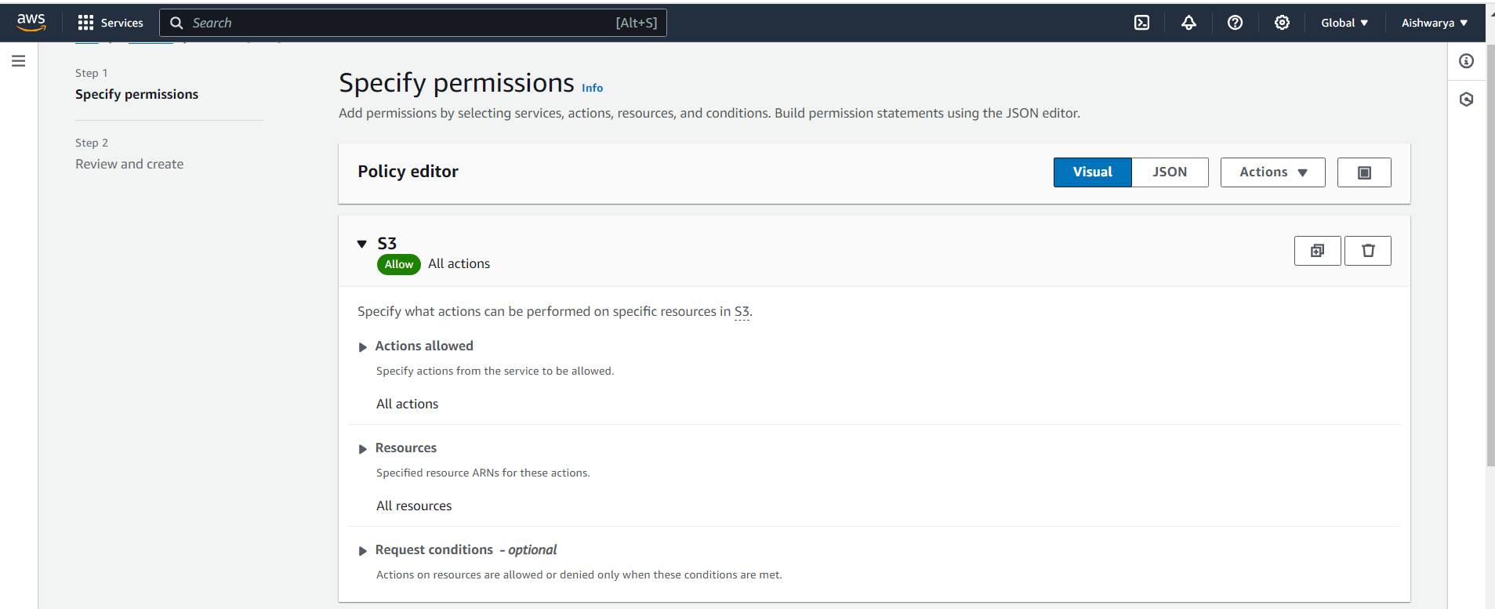

1. Only create EC2 instances

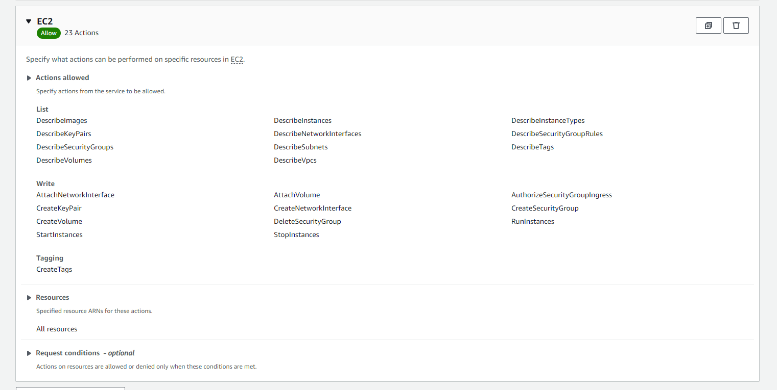

1. Full access to RDS

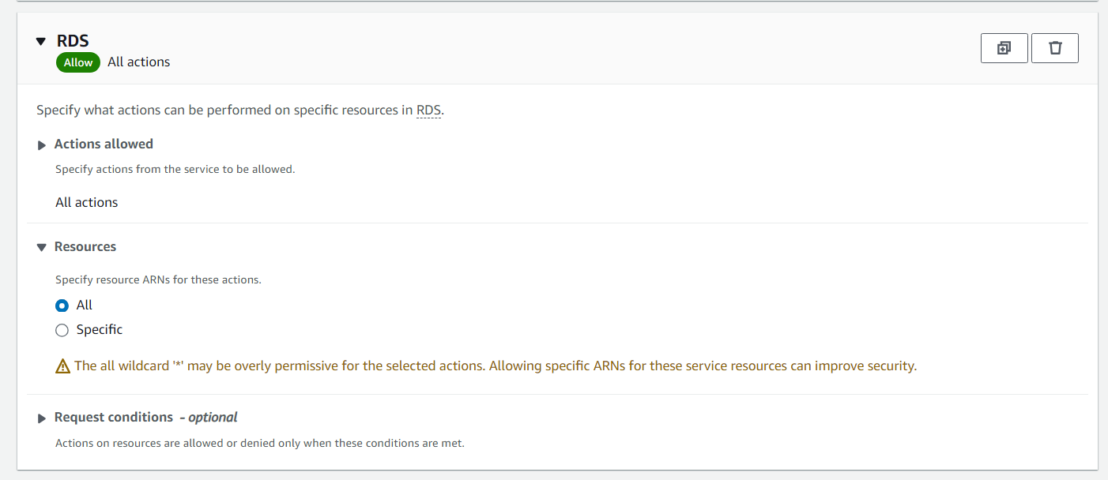

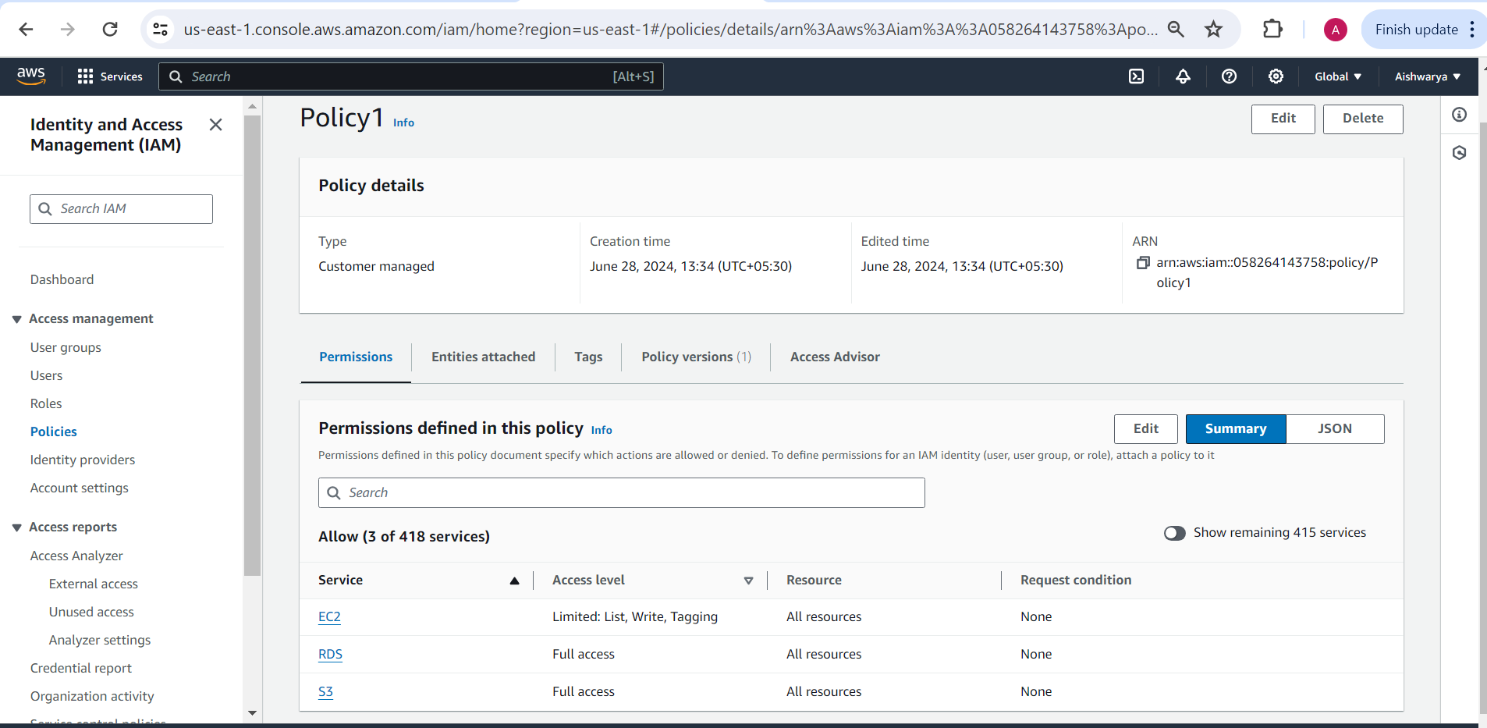

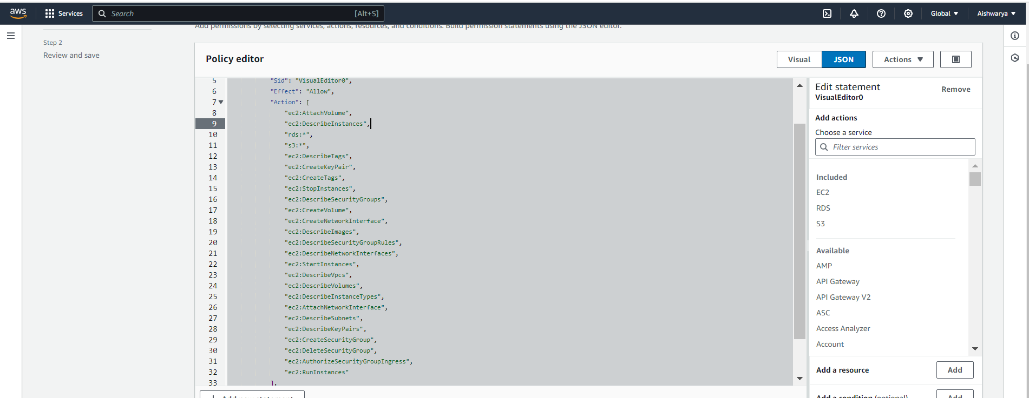

2. Create a policy number 2 which allows the users to:

a. Access CloudWatch and billing completely

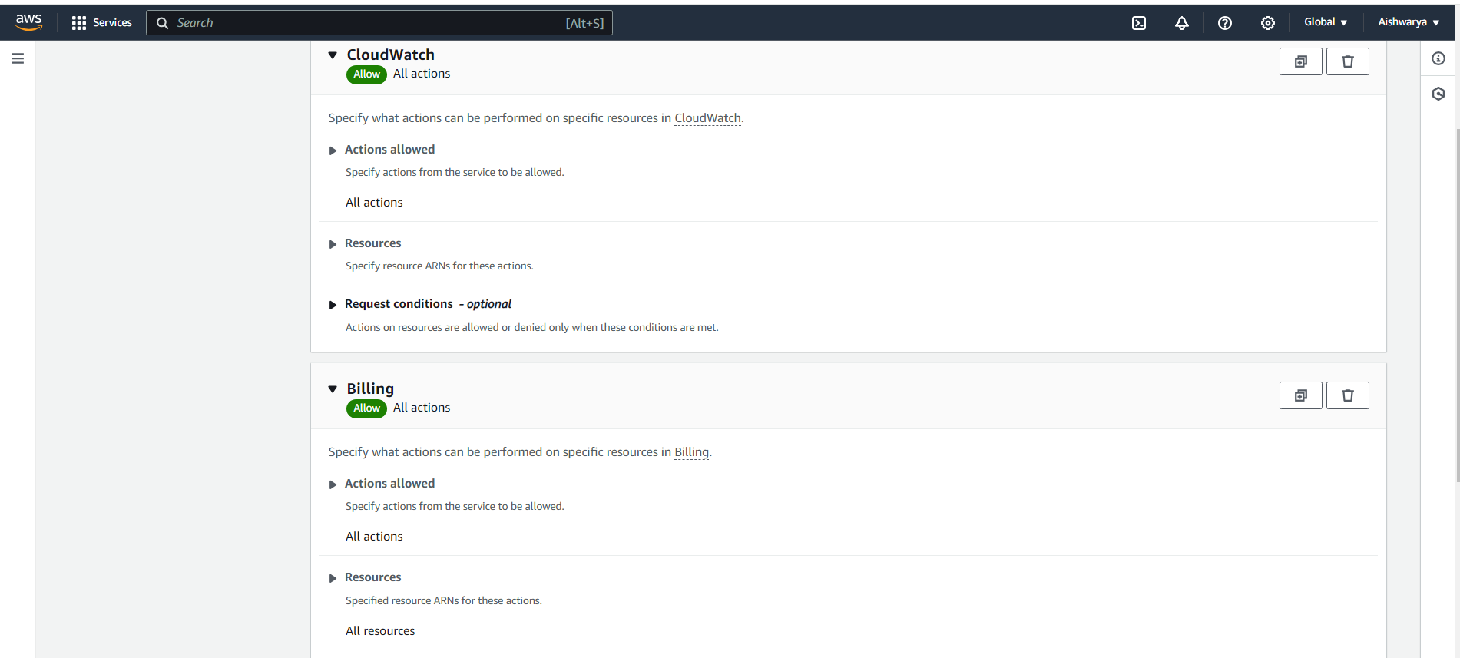

b. Can only list EC2 and S3 resources

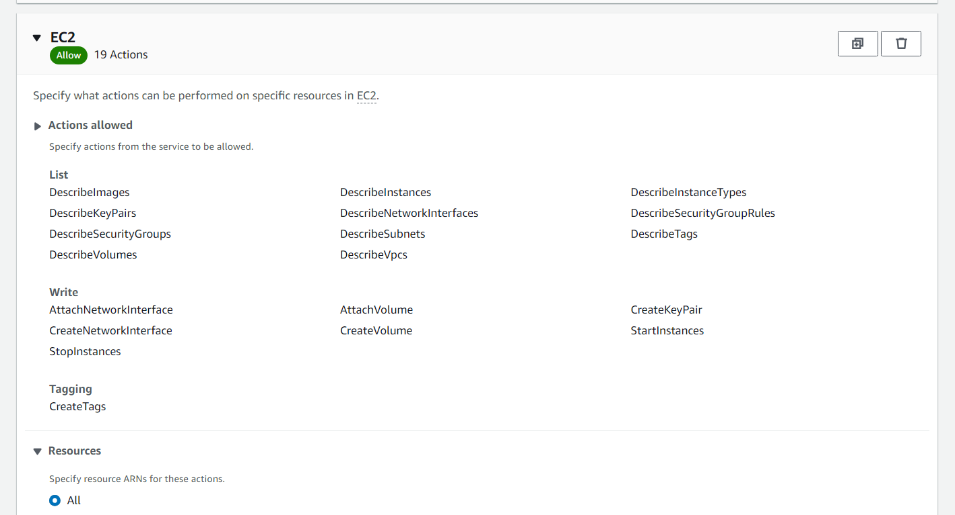

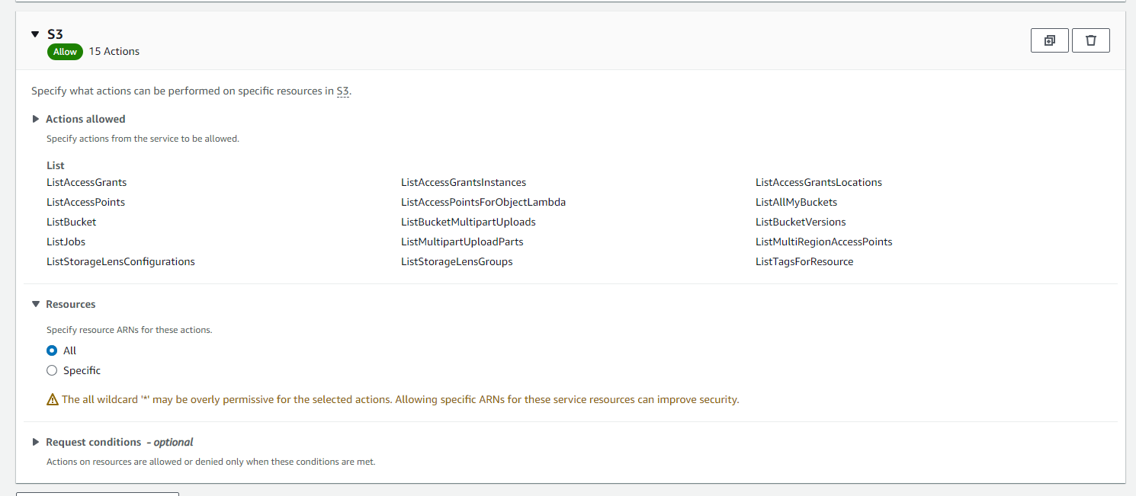

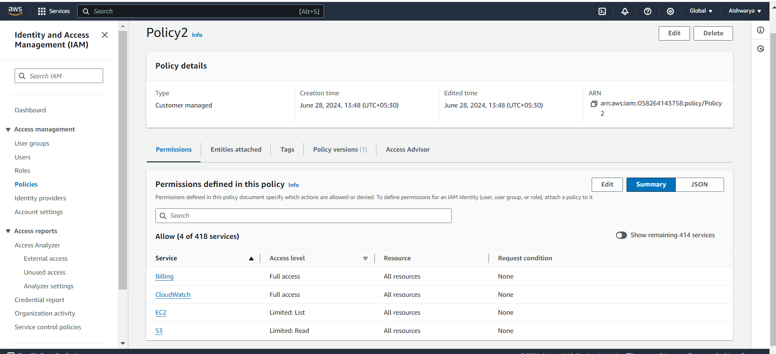

1. Attach policy number 1 to the Dev Team from task 1

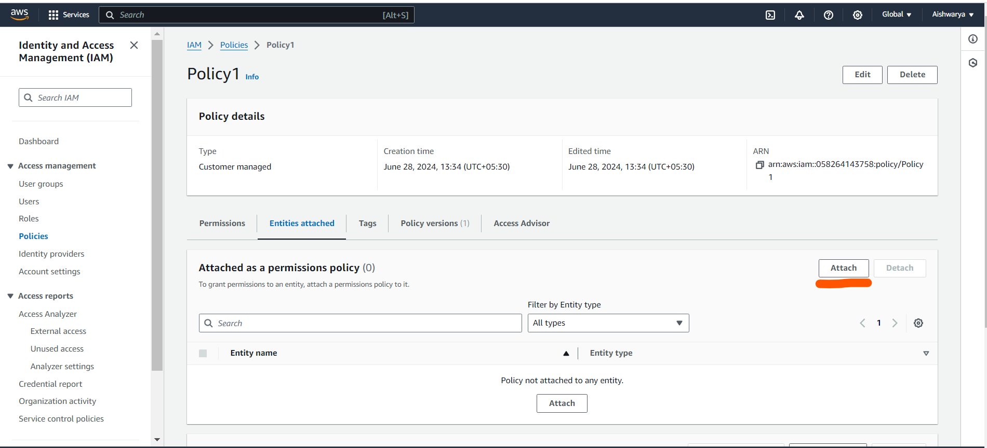

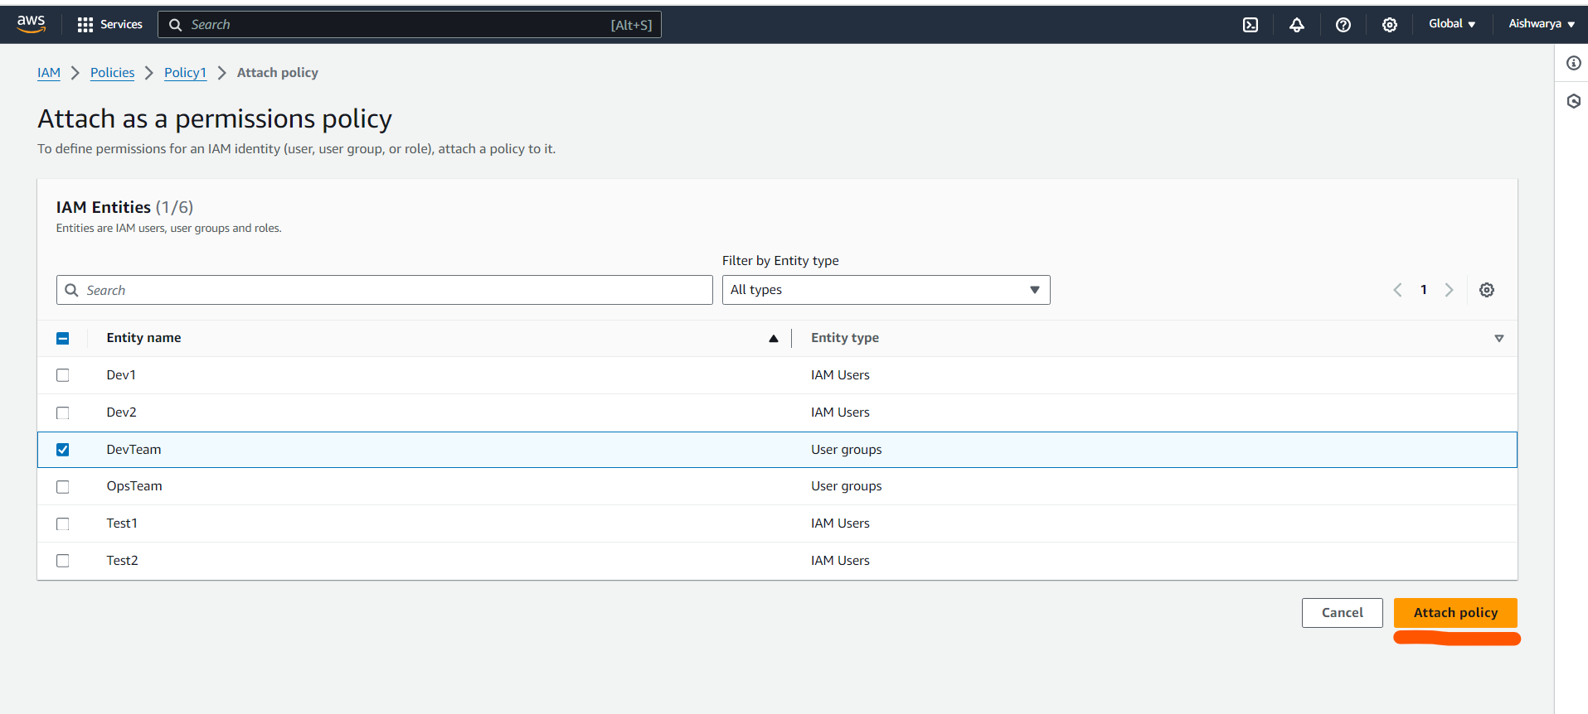

1. Attach policy number 2 to Ops Team from task 1

